Historical Documents
- The Declaration of Independence
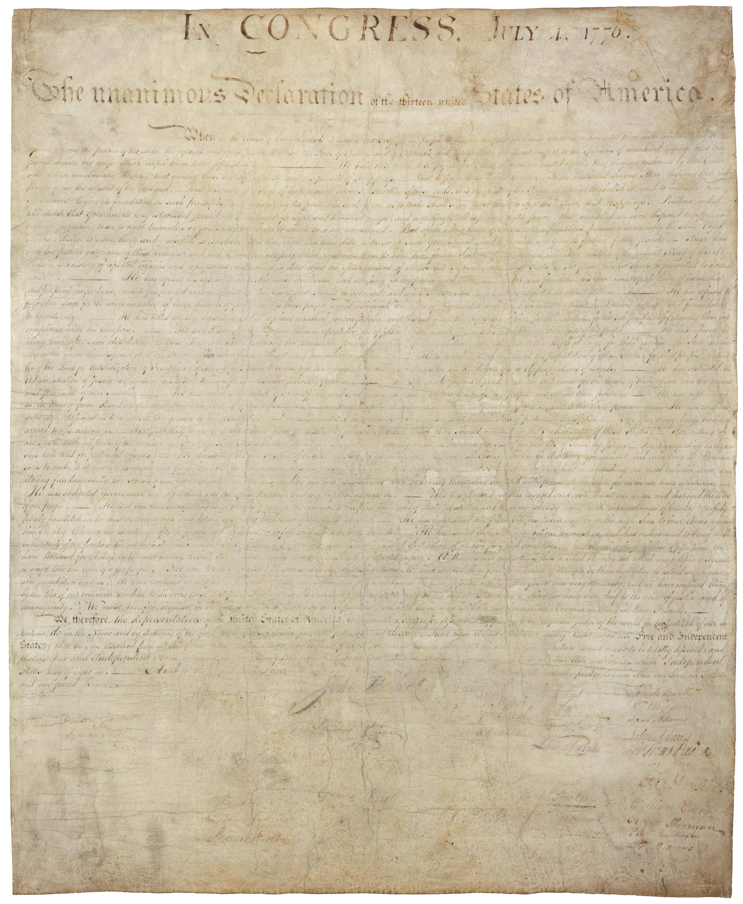The Declaration of Independence

1787 Convention Proceedings and Delegate Credentials

Letters of the Founders

The Constitution and Amendments in one page
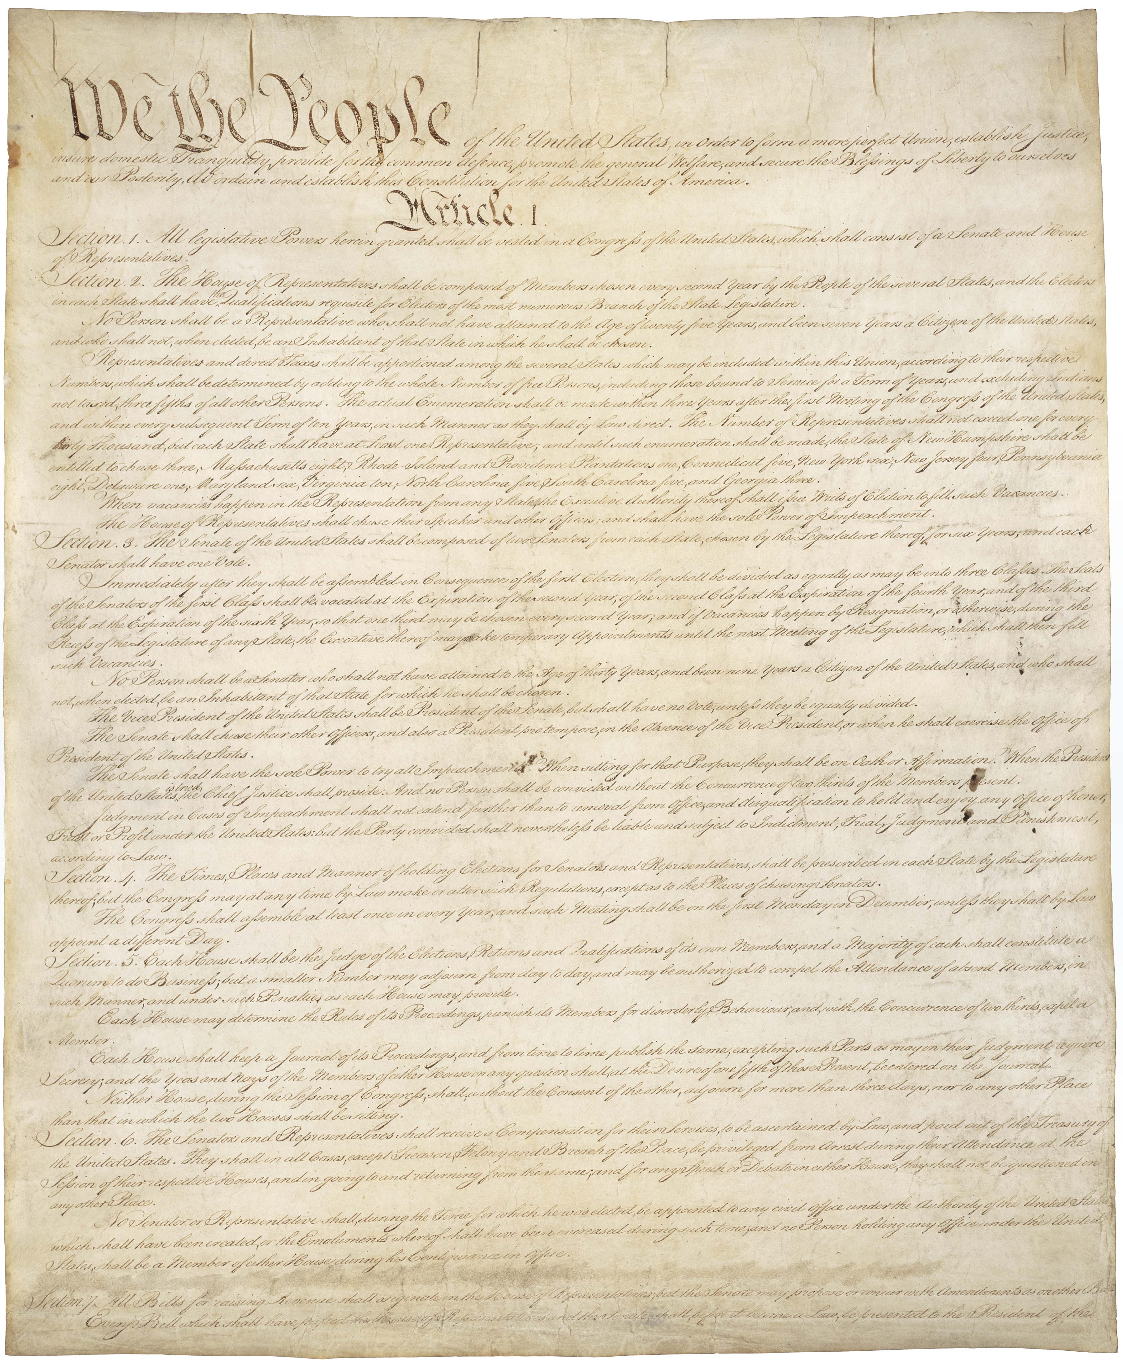The Constitution

- U.S. Constitution
  - Article V

- The Bill of Rights, Amendments 1-10
- The Constitution: Amendments 11-27

The Federalist and Anti-Federalist Papers
- Federalist Papers
- Anti-Federalist Papers

The Articles of Confederation, which preceded the Constitution
- Articles of Confederation
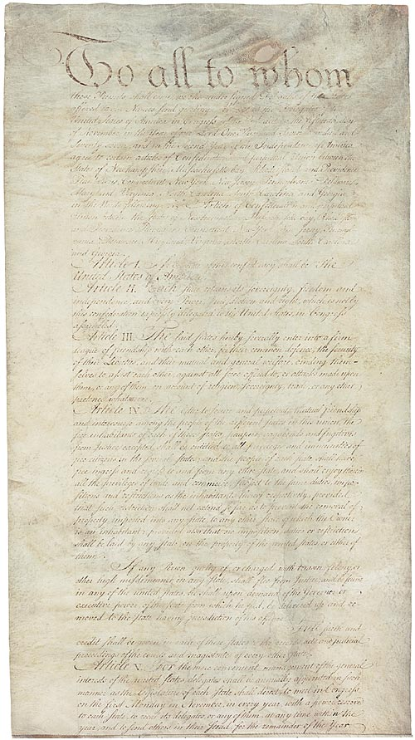AOC

Share this page Wiki Address: https://wiki.conventionofstates.com
Convention of States Youtube Channel
Convention of States on Rumble

Sign the COS Petition, be a leader https://conventionofstates.com/take_action
Volunteer here https://conventionofstates.com/take_action/volunteer

(540)441-7227 | CONVENTIONOFSTATES.COM | Facebook.com/ConventionOfStates | Twitter.com/COSproject| Email us

