An Intermediate Understanding of Article V
The Patriots Study of Convention of States Project and Article V

Video
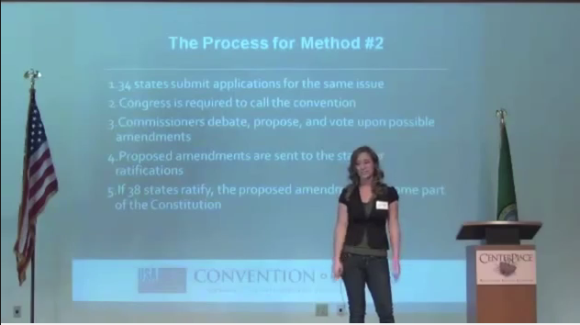
Overview of the COS Project at Washington Freedom Summit
Laura Fennig covers the process and history of Article V
Mark Meckler at Article V Symposium, March 27, 2014
Michael Farris at Article V Symposium
Public Meeting at Fort Wayne with Bob Berry, Travis Holdman, and Mark Meckler

Continue Reading here:

Convention of States application
To be passed in each state's legislature.
COS Application

The State Legislative procedure
The procedures followed by the States explained.
Legislative Procedure

Convention of States Handbook
The Case for a Convention of States
COS Handbook

Sign the Convention of States Petition http://www.cosaction.com/

