Article 22 - Article V Process
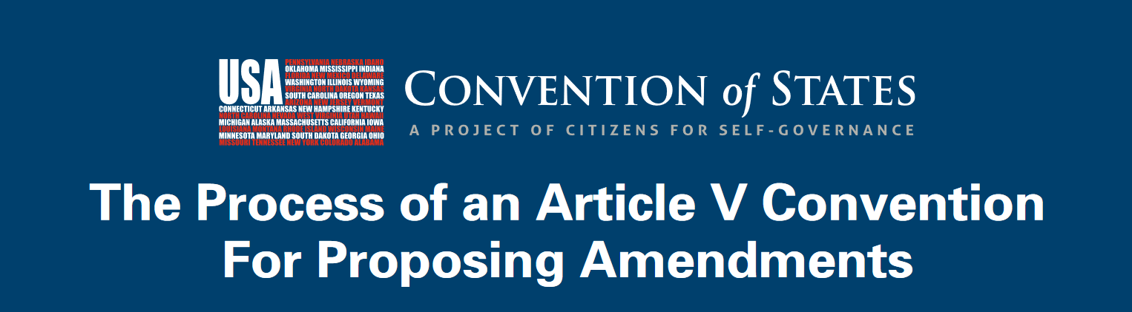
Download PDF, Article 22 - Article V Process

The Process of an Article V Convention For Proposing Amendments
34 STATE LEGISLATURES APPLY FOR A CONVENTION TO PROPOSE AMENDMENTS ON A SPECIFIED TOPIC
- The topics specified in the applications must be the same, in order for them to aggregate.
- The topics in the aggregated applications set the agenda for the Article V Convention.
CONGRESS “CALLS” THE ARTICLE V CONVENTION, BY SETTING THE TIME AND PLACE
- The entity that “calls” the meeting does not exercise any authority other than setting the time and place.
- Issuing the call is a ministerial duty.
THE STATES SELECT, INSTRUCT, AND SEND DELEGATES TO THE AMENDMENT-PROPOSING CONVENTION
- All states can participate, even those that did not apply.
- States select the delegates who will act as their agents at the convention, and instruct them on the scope of their authority.
CONVENTION OCCURS.
PROPOSED AMENDMENTS SUPPORTED BY THE MAJORITY OF
STATE DELEGATIONS ARE SENT TO THE STATES FOR RATIFICATION.
- States may send as many delegates as they choose, but each state only gets one vote when the convention begins.
CONGRESS SELECTS THE METHOD OF STATE RATIFICATION
- By the specific terms of Article V, Congress must choose between two options for state ratification: ratification by state legislatures or by state ratifying conventions.
PROPOSED AMENDMENTS ONLY BECOME EFFECTIVE IF RATIFIED BY 38 STATES
- It only takes 13 states to stop a bad amendment.
THE CONSTITUTION IS AMENDED
- By asserting your constitutional power under Article V, you can act as a final check on rampant federal overreach, and restore the proper balance of power.
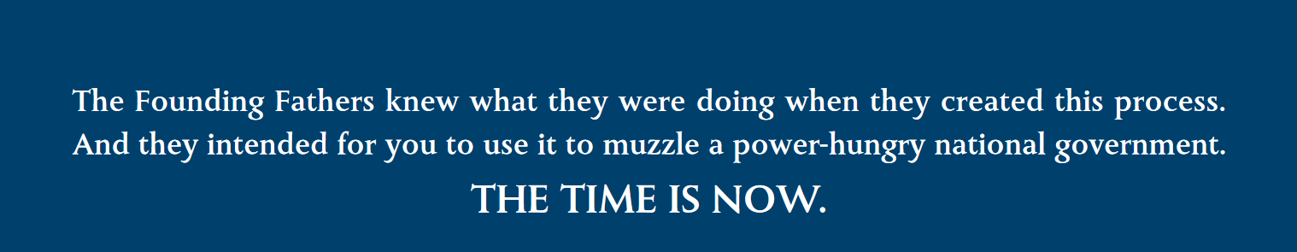The Founding Fathers knew what they were doing when they created this process. \\ And they intended for you to use it to muzzle a power-hungry national government. \\ THE TIME IS NOW.

The Founding Fathers knew what they were doing when they created this process.
And they intended for you to use it to muzzle a power-hungry national government.
THE TIME IS NOW.

The restrictions, limitations, and controls on the Article V process include all of the following, acting in conjunction:
- The convention’s agenda is set by the 34 state applications (for the Convention of States Project, amendment proposals must “impose fiscal restraints on the federal government, limit the power and jurisdiction of the federal government, and limit the terms of office for its officials and for members of Congress”);
- Once 34 states apply for a convention on the same topic and the convention is called, state legislatures select and instruct their delegates;
- At the convention, any single delegate can object to off-topic proposals as “out of order,” for which the objection must be sustained;
- At the convention, a majority of the states must vote in favor of any proposal in order for it to advance to the ratification stage;
- Any delegate who proposes or votes in favor of an amendment beyond the scope of the agreed agenda OR beyond the scope of his/her state legislature’s instructions can be recalled by the state legislature and subjected to penalties according to state law;
- Because delegates act as the agents of their state legislatures, a delegate's vote that exceeds his/her instructions or authority is void;
- The courts could be called upon, if needed, to protect the process at any point (there are abundant precedents demonstrating that, in fact, the courts DO acknowledge and protect the historical Article V procedures);
- 38 states must ratify any proposed amendments for them to become effective. This means that itonly takes 13 states to block a bad proposal.

Sign the COS Petition, be a leader https://conventionofstates.com/take_action
Volunteer here https://conventionofstates.com/take_action/volunteer
(540)441-7227 | CONVENTIONOFSTATES.COM | Facebook.com/ConventionOfStates | Twitter.com/COSproject| Email us

