Group Support

Social Media Resources
Here are some quick answers useful for supporting Convention of States Project on Social Media

Social Media Sites

Facebook
https://www.facebook.com/conventionofstates/

Twitter
https://twitter.com/cosproject

LinkedIn
https://www.linkedin.com/company-beta/11150441/

Youtube
https://www.youtube.com/channel/UCC0eXtGEMvjxpdYQl2LUiVw

Rumble
Convention of States on Rumble

Instagram
Log in and search for: conventionofstates
Read more here: http://www.conventionofstates.com/introducing_instagram_convention_of_states_style

Action
- Have you signed the petition?
The petition goes to your state Rep & state Senator based on your address & is vital in getting them to get on board and shows your support. Click this direct link to sign the petition http://www.cosaction.com/
- We encourage you to “create your account” on our site http://www.conventionofstates.com. Your activist dashboard may show a local COS leader in the sidebar on the right with an email link to contact them. They can help get you involved in your area. If there is no local point person listed, maybe you could become that volunteer & help others get involved.
- We have lots of volunteer options here:
www.conventionofstates.com/volunteer

The Plan
A convention of states is a convention called by the state legislatures for the purpose of proposing amendments to the Constitution. They are given power to do this under Article V, Section 2 of the Constitution.
COS Plan for convention
We advocate for the use of Article V of the Constitution to call a convention for the states to propose amendments to reduce the power and jurisdiction of the federal govt., impose fiscal restraints on their spending, limit the terms of all federal officials. Video Here is a great short video that explains the Article V process: [Convention of States – Alabama]
And another longer one:
In just 15 enlightening minutes, learn why and how we are invoking Article V of the Constitution to call a Convention of States and restore America, just as the Founders intended: PrezIntro

ARTICLE V - What Article V says:
Learn Article V
and on the Wiki

Article. V.
The Congress, whenever two thirds of both Houses shall deem it necessary, shall propose Amendments to this Constitution, or, on the Application of the Legislatures of two thirds of the several States, shall call a Convention for proposing Amendments, which, in either Case, shall be valid to all Intents and Purposes, as Part of this Constitution, when ratified by the Legislatures of three fourths of the several States, or by Conventions in three fourths thereof, as the one or the other Mode of Ratification may be proposed by the Congress; Provided that no Amendment which may be made prior to the Year One thousand eight hundred and eight shall in any Manner affect the first and fourth Clauses in the Ninth Section of the first Article; and that no State, without its Consent, shall be deprived of its equal Suffrage in the Senate.

Convention of States Application
- The Convention of States Application (PDF)

Convention for Proposing Amendments -- Proposed Rules
- The rules presented to the legislators are only a draft. They are based on the historical record of interstate conventions, and Mason's Manual of Legislative Procedure used by most state legislatures. But now, legislators will be spending some time hashing out some of the finer details through an online, interactive portal we've created for them.
http://www.conventionofstates.com/proposed_rules
- Prof. Rob Natelson Introduces Draft of Convention of States Rules:
https://www.youtube.com/watch?v=-4140az60vo&list=PL8h4sleiAEjXrSwDCvfuk9BomrCdgFZGj&index=4

Legislative Procedure
Legislative Procedure (PDF)

The Liberal Establishment’s Disinformation Campaign Against Article V
Article V Disinfo Campaign (PDF)

Which amendments could be proposed?
These are possible amendments that could be proposed.

COS Handbook
- COS Handbook (PDF)
A handbook for Legislators and Citizens

Article V Handbook
- ALEC: Article V Handbook PDF
American Legislative Exchange Council: A HANDBOOK FOR STATE LAWMAKERS

Convention of States Project launches legislator caucus and website
at American Legislative Exchange Council meeting
http://www.conventionofstates.com/convention_of_states_project_launches_legislator_caucus

Share this page Wiki Address: https://wiki.conventionofstates.com
Convention of States Youtube Channel
Convention of States on Rumble

Sign the COS Petition, be a leader https://conventionofstates.com/take_action
Volunteer here https://conventionofstates.com/take_action/volunteer

(540)441-7227 | CONVENTIONOFSTATES.COM | Facebook.com/ConventionOfStates | Twitter.com/COSproject| Email us

Legislators Page


COS Project State Pages
Call or email your legislator (bottom of page)

Documents
 Selected Documents that Legislators should be familiar with:
- And
Frequently Asked Questions And Responses to Opposition Arguments
FAQ
Responses to Opposition Arguments
- COS Handbook
(PDF)
A handbook for Legislators and Citizens
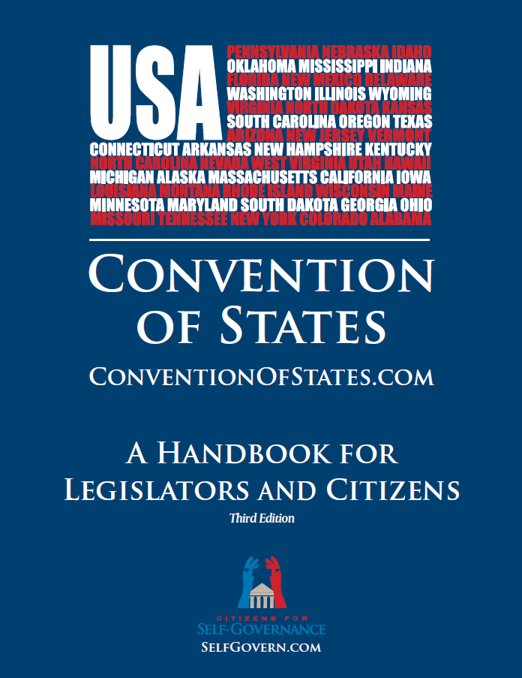COS Handbook
- Article V Handbook PDF
A HANDBOOK FOR STATE LAWMAKERS
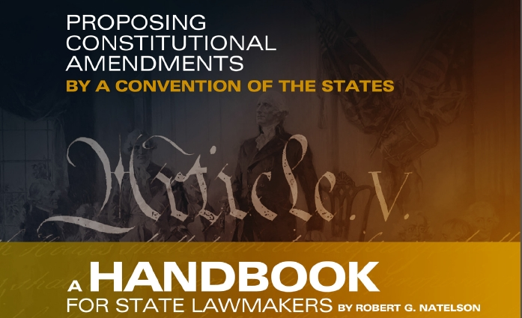Article V Handbook
- Indiana's Model Legislation for Delegates PDF Slideshow Summary[PDF]
Includes an overview of Article V
(Video)Q and A | Indiana Senate President David Long 2014
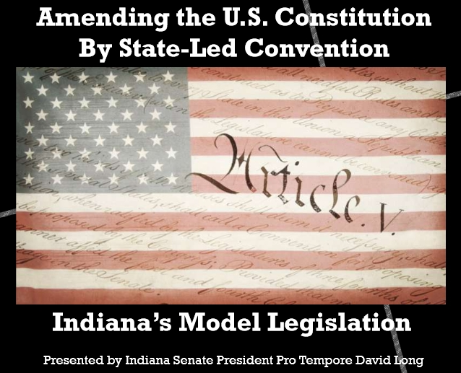Indiana's Model Legislation for Delegates
- Faithful Delegate Laws - All current states
- The Convention of States Application PDF
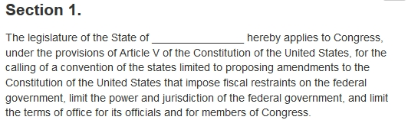Convention of States Application
- Proposed Convention Rules
Professor Rob Natelson, one of the nation’s leading Article V experts, crafted an initial draft of rules for a Convention of the States along with Convention of States Project co-founder, Michael Farris
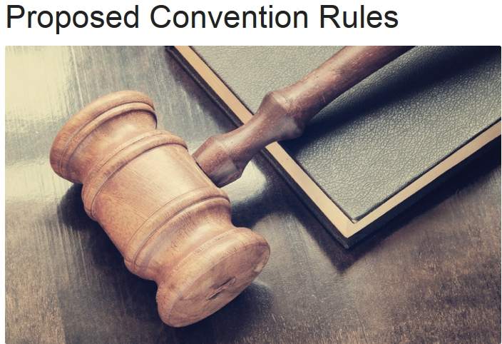Proposed Convention Rules
- Article V Legislative Compendium PDF
-- The Article V Compendium for Lawyers and Legislative Drafters was written by premier Article V scholar Professor Rob Natelson. It includes over 80 pages of original material as well as important and reliable scholarly articles on the laws governing amendment conventions.
The Wiki format has a live table of contents, end notes, links, etc.
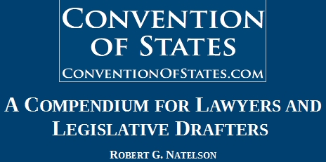Article V Legislative Compendium

External Links

Article V Information Center
Our American Constitution - Independence Institute
State Legislators Article V Caucus
State Legislators Article V Caucus

Video
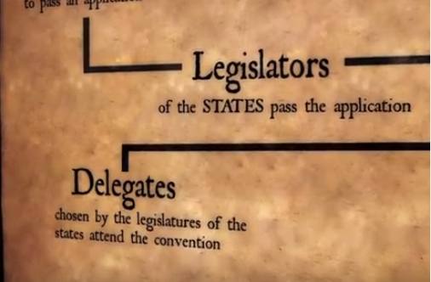
Video: Convention of States - Alabama
An excellent video explaining the Article V process
Video: Convention of States - Now is the Time!
A brief overview of why the Framers gave us the convention mode in Article V and quotes from them and past presidents that supported this constitutional provision
Leaders Among Leaders
Become a Leader today in YOUR Legislature!
Video: Rep. Scot Turner on Convention of States
Georgia State Rep. Scot Turner on why he now supports Convention of States. Georgia became the first state to pass our resolution in February 2014
Video: Convention of States: The Plan to Restore America
Video: Rep. Michelle Gray of Arkansas explains why she changed her vote to YES
Rep Michelle Gray of Arkansas explains why she changed her vote to yes during the reconsideration vote for HJR1003.
Video: Robert Menges testimony before South Carolina Senate Judiciary Meeting
Robert Menges testimony before South Carolina Senate Judiciary Meeting, answering the questions, what role does Congress play in the Article V Convention of States?
Video: Interview with Arizona Rep. Kelly Townsend
Arizona State Representative Kelly Townsend answers questions like, Why do you support Convention of States and How will the Convention of States Caucus help the movement?
Video: Interview with Florida Rep. Mike Hill
Florida State Representative Mike Hill explains why the federal government will not fix itself and how the states can do it for them.
Video: Interview with Arizona Sen. Nancy Barto
Arizona State Senator Nancy Barto answers questions like, Why is a Convention of States seeing so much support? and What is the biggest problem we face in America?
Video: Rep. Ken Ivory Discusses Rules for Article V Convention
In this video, Utah State Representative Ken Ivory discusses the rules for an Article V Convention that were proposed by the Convention of States Caucus.
Video: Rep. Robin Lundstrum on a Convention of States
Arkansas State Representative Robin Lundstrum briefly explains to Tami Greever and Curtis Coleman why she's supporting Arkansas' application for a Convention of States
Video: Prof. Rob Natelson Introduces Draft of Convention of States Rules
Leading Article V expert Professor Rob Natelson introduces draft of Convention of States rules that will be further debated and discussed by members of the Convention of States Caucus.
Video: Mark Meckler's Address at Convention of States Workshop
Mark Meckler, President and Founder of Citizens for Self-Governance and co-founder of the Convention of States Project, inspires and encourages state legislators to use Article V to rein in the power of Washington, D.C.
Video: Convention of the States Florida 2015 Simulation Recap
In July 2015, the first Article V simulation was held in Florida, with over thirty attending. After there were over eighty amendments proposed, the commissioners, through floor and committee debate and revisions, were able to narrow that number down to six amendments.

Youtube Video: Citizens for Self-Governance: Convention of States Project Youtube Channel

COS Surge Article Library
COS Surge Article Library

