Legislators Page


COS Project State Pages
Call or email your legislator (bottom of page)

Documents
 Selected Documents that Legislators should be familiar with:
- And
Frequently Asked Questions And Responses to Opposition Arguments
FAQ
Responses to Opposition Arguments
- COS Handbook
(PDF)
A handbook for Legislators and Citizens
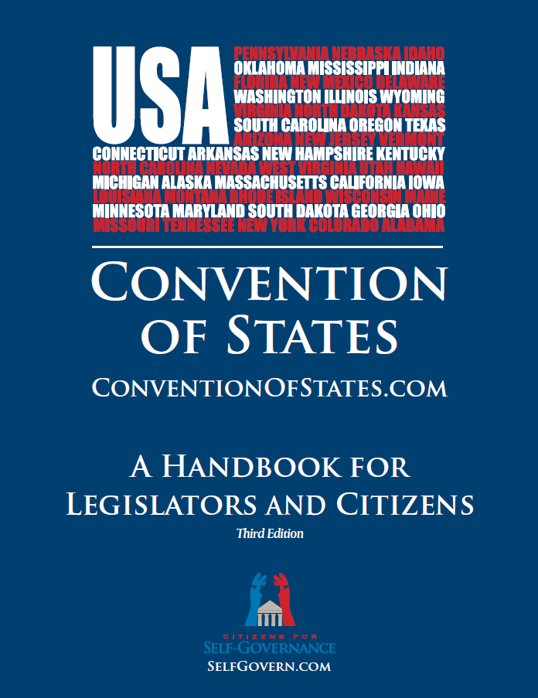COS Handbook
- Article V Handbook PDF
A HANDBOOK FOR STATE LAWMAKERS
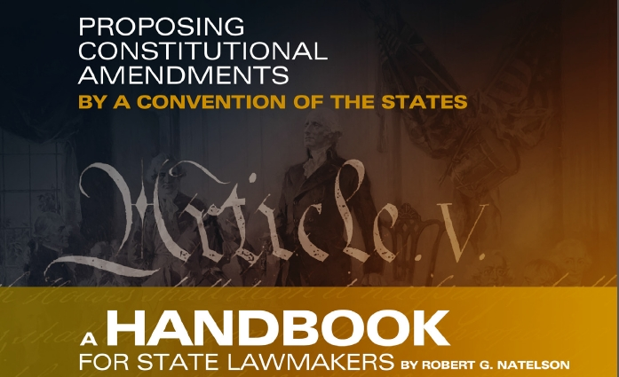Article V Handbook
- Indiana's Model Legislation for Delegates PDF Slideshow Summary[PDF]
Includes an overview of Article V
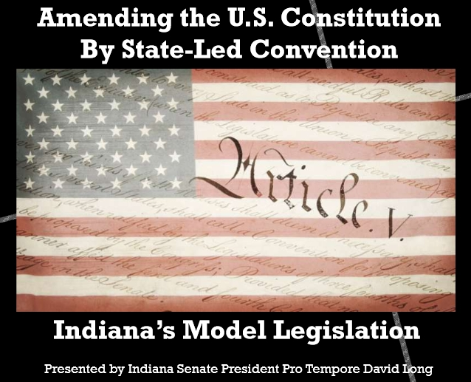Indiana's Model Legislation for Delegates
- The Convention of States Application PDF
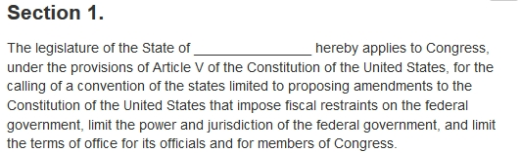Convention of States Application
- Proposed Convention Rules
Professor Rob Natelson, one of the nation’s leading Article V experts, crafted an initial draft of rules for a Convention of the States along with Convention of States Project co-founder, Michael Farris
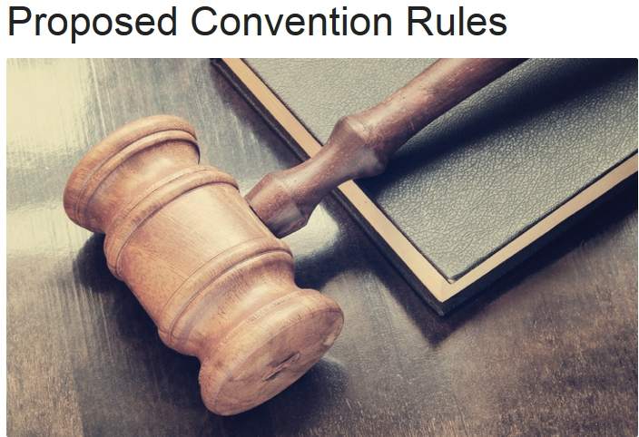Proposed Convention Rules
- Article V Legislative Compendium PDF
-- The Article V Compendium for Lawyers and Legislative Drafters was written by premier Article V scholar Professor Rob Natelson. It includes over 80 pages of original material as well as important and reliable scholarly articles on the laws governing amendment conventions.
The Wiki format has a live table of contents, end notes, links, etc.
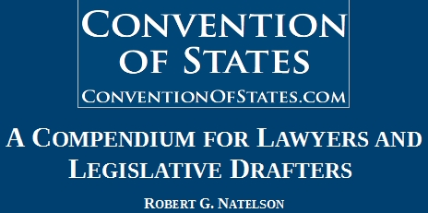Article V Legislative Compendium

External Links

Article V Information Center
Our American Constitution - Independence Institute
State Legislators Article V Caucus
State Legislators Article V Caucus

Video
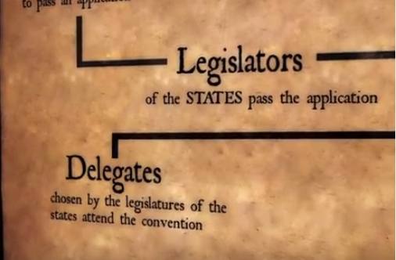
Video: Convention of States - Alabama
An excellent video explaining the Article V process
Video: Convention of States - Now is the Time!
A brief overview of why the Framers gave us the convention mode in Article V and quotes from them and past presidents that supported this constitutional provision
Leaders Among Leaders
Become a Leader today in YOUR Legislature!
Video: Rep. Scot Turner on Convention of States
Georgia State Rep. Scot Turner on why he now supports Convention of States. Georgia became the first state to pass our resolution in February 2014
Video: Convention of States: The Plan to Restore America
Video: Rep. Michelle Gray of Arkansas explains why she changed her vote to YES
Rep Michelle Gray of Arkansas explains why she changed her vote to yes during the reconsideration vote for HJR1003.
Video: Robert Menges testimony before South Carolina Senate Judiciary Meeting
Robert Menges testimony before South Carolina Senate Judiciary Meeting, answering the questions, what role does Congress play in the Article V Convention of States?
Video: Interview with Arizona Rep. Kelly Townsend
Arizona State Representative Kelly Townsend answers questions like, Why do you support Convention of States and How will the Convention of States Caucus help the movement?
Video: Interview with Florida Rep. Mike Hill
Florida State Representative Mike Hill explains why the federal government will not fix itself and how the states can do it for them.
Video: Interview with Arizona Sen. Nancy Barto
Arizona State Senator Nancy Barto answers questions like, Why is a Convention of States seeing so much support? and What is the biggest problem we face in America?
Video: Rep. Ken Ivory Discusses Rules for Article V Convention
In this video, Utah State Representative Ken Ivory discusses the rules for an Article V Convention that were proposed by the Convention of States Caucus.
Video: Rep. Robin Lundstrum on a Convention of States
Arkansas State Representative Robin Lundstrum briefly explains to Tami Greever and Curtis Coleman why she's supporting Arkansas' application for a Convention of States
Video: Prof. Rob Natelson Introduces Draft of Convention of States Rules
Leading Article V expert Professor Rob Natelson introduces draft of Convention of States rules that will be further debated and discussed by members of the Convention of States Caucus.
Video: Mark Meckler's Address at Convention of States Workshop
Mark Meckler, President and Founder of Citizens for Self-Governance and co-founder of the Convention of States Project, inspires and encourages state legislators to use Article V to rein in the power of Washington, D.C.
Video: Convention of the States Florida 2015 Simulation Recap
In July 2015, the first Article V simulation was held in Florida, with over thirty attending. After there were over eighty amendments proposed, the commissioners, through floor and committee debate and revisions, were able to narrow that number down to six amendments.

Youtube Video: Citizens for Self-Governance: Convention of States Project Youtube Channel

COS Surge Article Library
COS Surge Article Library

