COS Wiki Video

How to use the COS Wiki
These videos will assist finding more information on Article V and Convention of states using the COS Wiki. There are many documents of historical nature, Article V related, and Convention of States related topics. Learn now to navigate the Wiki structure, search the whole Wiki, and use the information in email, social media, articles, etc.

COS Wiki: Navigation
How to find information. How the Wiki is organized
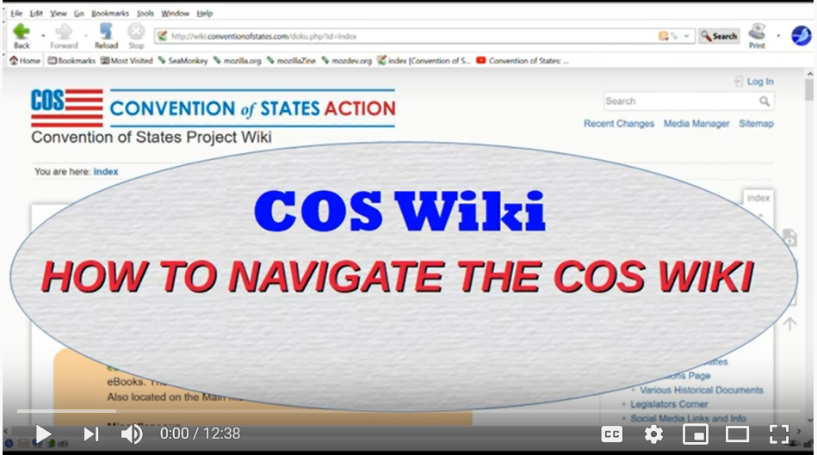
Wiki Navigation

COS Wiki: Search and Social Media
How to use search and use the results in social media.
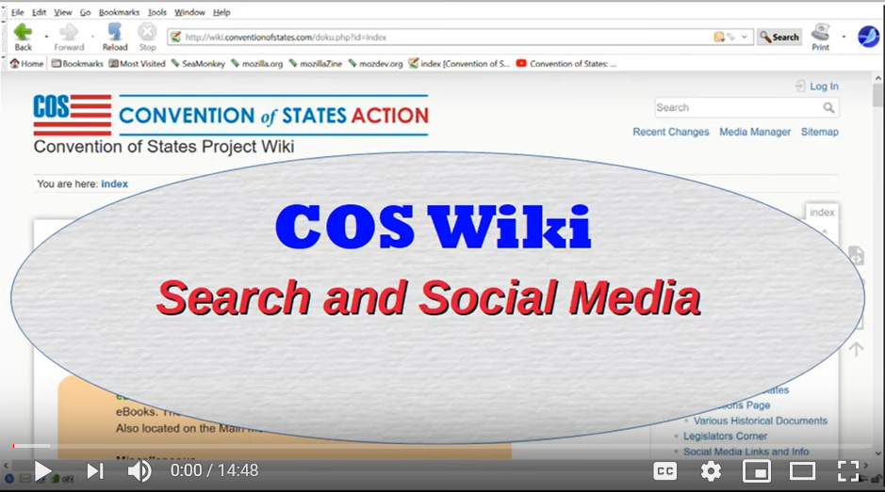
Search and Social Media

Share this page Wiki Address: https://wiki.conventionofstates.com
Convention of States Youtube Channel
Convention of States on Rumble

Sign the COS Petition, be a leader https://conventionofstates.com/take_action
Volunteer here https://conventionofstates.com/take_action/volunteer

(540)441-7227 | CONVENTIONOFSTATES.COM | Facebook.com/ConventionOfStates | Twitter.com/COSproject| Email us

