Historical Documents
- The Declaration of Independence
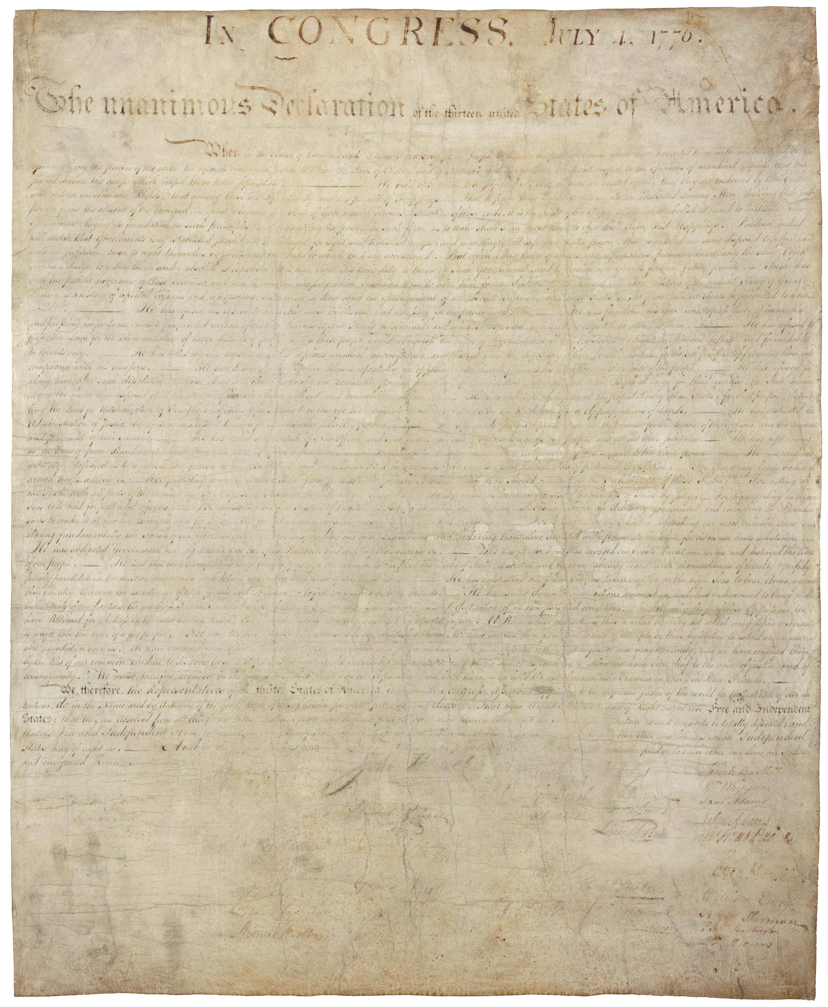The Declaration of Independence

The Constitution and Amendments in one page
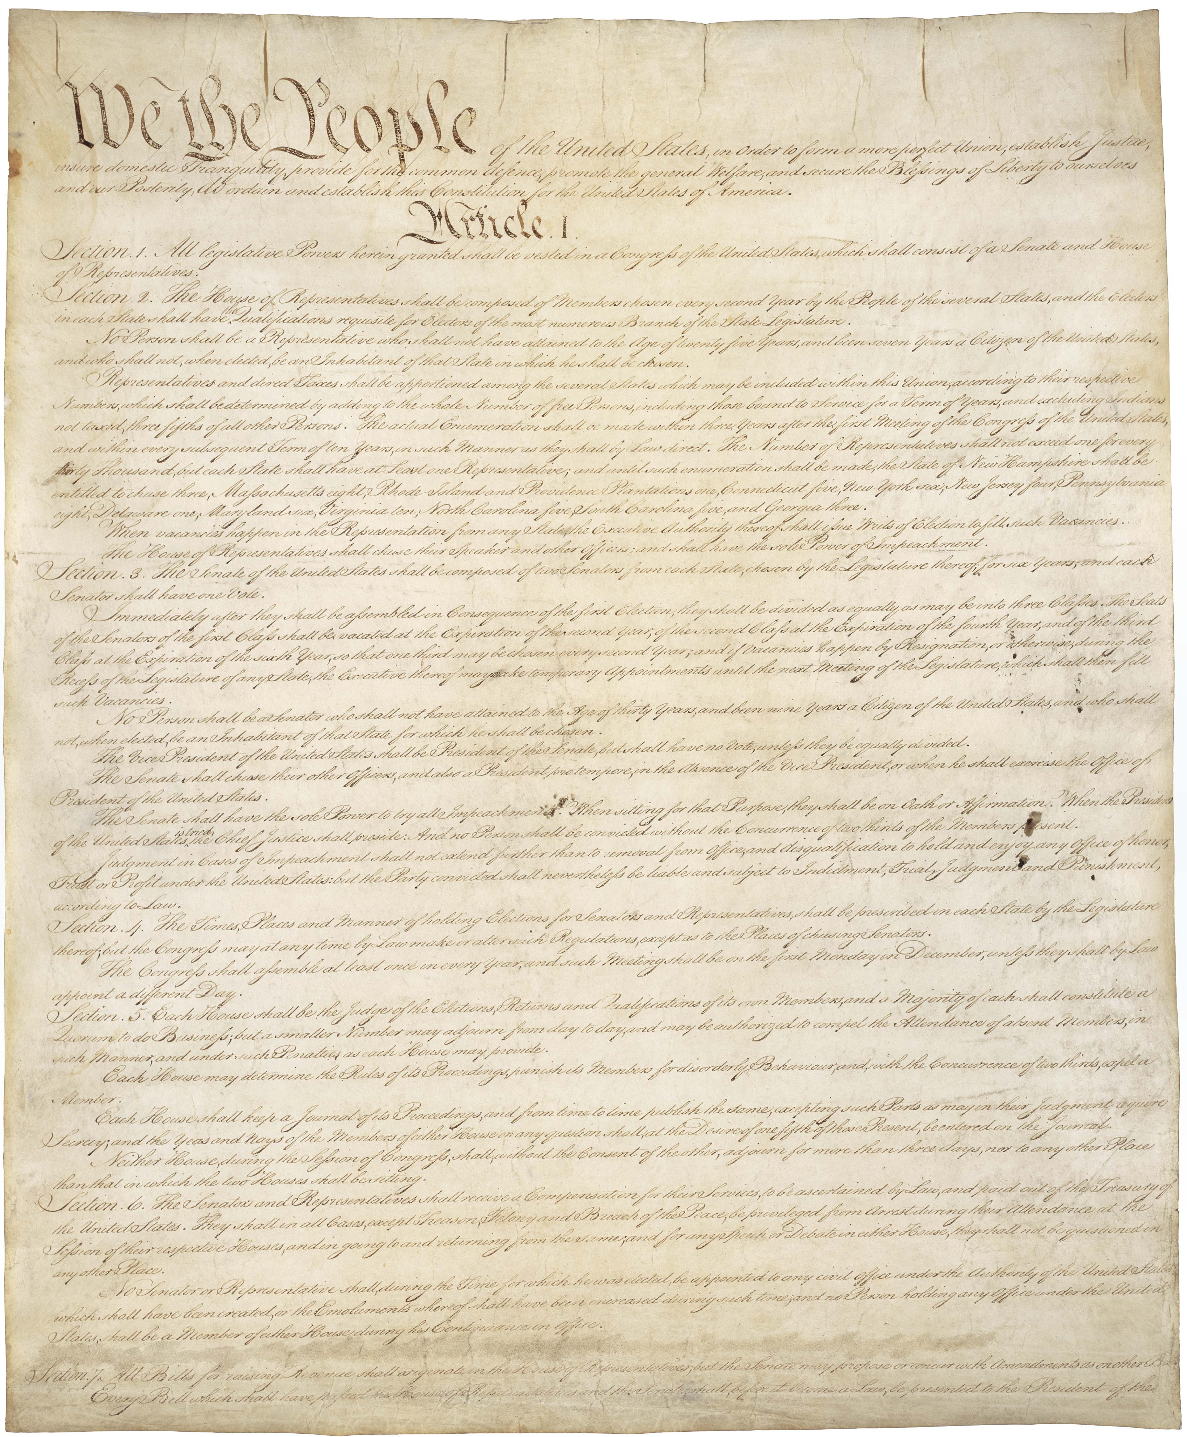The Constitution

- U.S. Constitution
  - Article V

- The Bill of Rights, Amendments 1-10
- The Constitution: Amendments 11-27

The Federalist and Anti-Federalist Papers
- Federalist Papers
- Anti-Federalist Papers

The Articles of Confederation, which preceded the Constitution
- Articles of Confederation
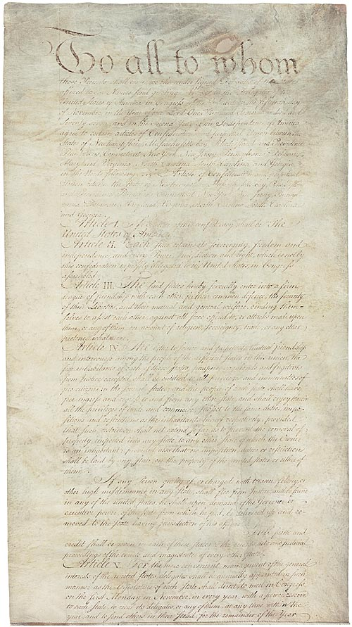AOC

