All Surge Documents

Article 1-Solution As Big As Problem
Download PDF, Article_1-Solution As Big As Problem
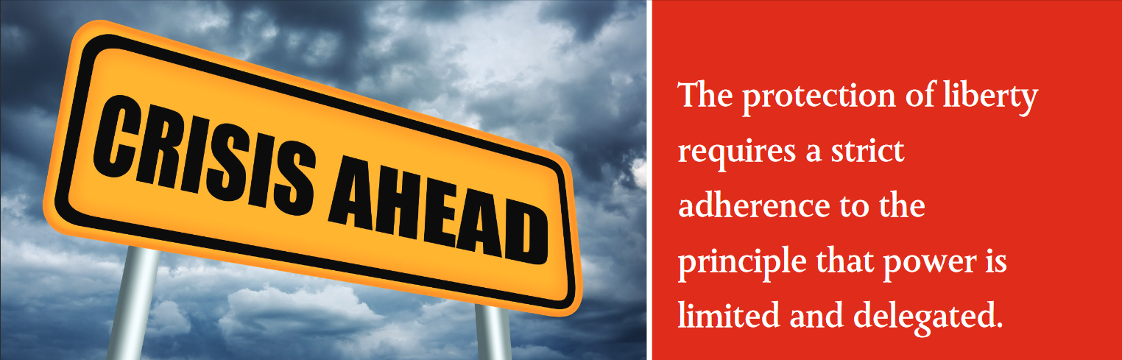The protection of liberty requires a strict adherence to the principle that power is limited and delegated.

A Solution As Big As The Problem
Michael P. Farris, JD, LLM, Convention of States Action — Senior Fellow for Constitutional Studies
We See Four Major Abuses Perpetrated by the Federal Government.
These abuses are not mere instances of bad policy. They are driving us towards an age of “soft tyranny” in which the government does not shatter men’s wills but “softens, bends, and guides” them. If we do nothing to halt these abuses, we run the risk of becoming nothing more than “a flock of timid and industrious animals, of which the government is the shepherd.”
(Alexis de Tocqueville, Democracy in America,1840)
1. The Spending and Debt Crisis
The $17 trillion national debt is staggering, but it only tells part of the story. Under standard accounting practices, the federal government owes around $100 trillion more in vested Social Security benefits and other pro-grams. This is why the government cannot tax its way out of debt. Even if it confiscated everything, it would not cover the debt.
2. The Regulatory Crisis
The federal bureaucracy has placed a regulatory burden upon businesses that is complex, conflicted, and crushing. Little account-ability exists when agencies—rather than Congress—enact the real substance of the law. Research from the American Enterprise Institute shows that, since 1949, federal regulations have lowered the real GDP growth by 2% and made America 72% poorer.
3. Congressional Attacks on State Sovereignty
For years, Congress has been using federal grants to keep the states under its control. Combining these grants with federal mandates (which are rarely fully funded), Congress has turned state legislatures into their regional agencies rather than respecting them as truly independent republican governments.
A radical social agenda and an invasion of the rights of the people accompany all of this. While significant efforts have been made to combat this social erosion, these trends defy some of the most important principles.
4. Federal Takeover of the Decision-Making Process
The Founders believed that the structures of a limited government would provide the greatest protection of liberty. Not only were there to be checks and balances between the branches of the federal government, but power was to be shared between the states and federal government, with the latter only exercising those powers specifically granted in the Constitution.
Collusion among decision-makers in Washington, D.C., has replaced these checks and balances. The federal judiciary supports Congress and the White House in their ever-escalating attack upon the jurisdiction of the fifty states.
We need to realize that the structure of decision-making matters. Who decides what the law shall be is as important as what is decided. The protection of liberty requires a strict adherence to the principle that power is limited and delegated.
Washington, D.C., does not believe in this principle, as evidenced by an unbroken practice of expanding the boundaries of federal power. In a remarkably frank admission, the Supreme Court rebuffed a challenge to federal spending power, despite acknowledging that power had grown far beyond the bounds envisioned by the Founders.
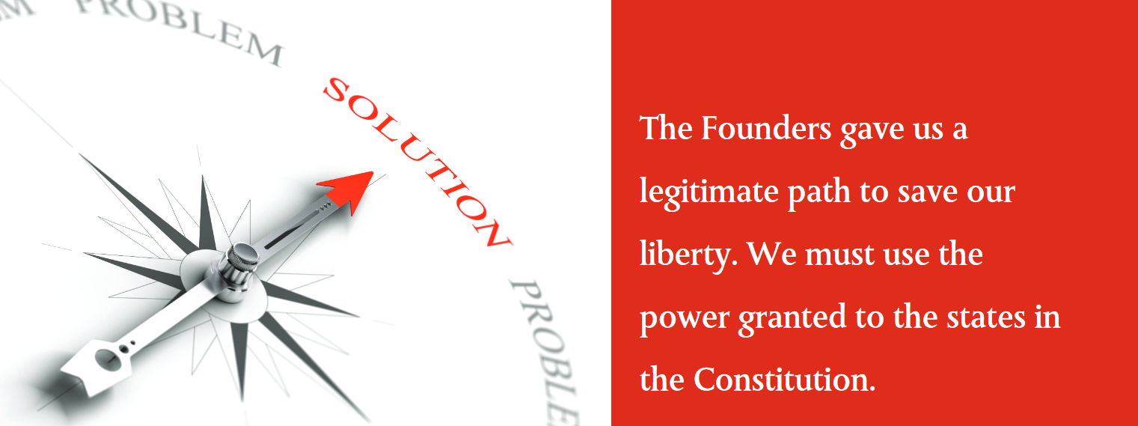The Founders gave us a legitimate path to save our liberty. We must use the power granted to the states in the Constitution.

What Does this Mean?
This is not a partisan issue. Washington, D.C., will never voluntarily relinquish meaningful power—no matter who is elected. The only rational conclusion is this: Unless some political force outside of Washington, D.C., intervenes, the federal government will continue to bankrupt this nation, embezzle the legitimate authority of the states, and destroy the liberty of the people. Rather than securing the blessings of liberty for future generations, Washington, D.C., is on a path that will enslave our children and grandchildren to the debts of the past. The problem is big, but we have a solution. Article V gives us a tool to fix the mess in D.C.
Our Solution Is Big Enough to Solve the Problem
Rather than calling a convention for a specific amendment, Convention of States Action (COSA) urges state legislatures to properly use Article V to call a convention for a particular subject—reducing the power of Washington, D.C. It is important to note that a convention for an individual amendment (e.g., a Balanced Budget Amendment) would be limited to that single idea. Requiring a balanced budget is a great idea that COSA fully supports. Congress, however, could comply with a Balanced Budget Amendment by simply raising taxes. We need spending restraints as well. We need restraints on taxation. We need prohibitions against improper federal regulation. We need to stop unfunded mandates.
A Convention of States needs to be called to ensure that we are able to debate and impose a complete package of restraints on the misuse of power by all branches of the federal government.
What Sorts of Amendments Could Be Passed?
The following are examples of amendment topics that could be discussed at a conven-tion of states:
- A Balanced Budget Amendment
- A redefinition of the General Welfare Clause (the original view was that the federal government could not spend money on any topic within the jurisdiction of the states)
- A redefinition of the Commerce Clause (the original view was that Congress was granted a narrow and exclusive power to regulate shipments across state lines–not all the economic activity of the nation)
- A prohibition on using international treaties and law to govern the domestic law of the United States
- A limitation on using executive orders and federal regulations to enact laws (since Congress is supposed to be the exclusive agency to enact laws)
- Imposing term limits on Congress and the Supreme Court
- Placing an upper limit on federal taxation
- Requiring the sunset of all existing federal taxes and a super-majority vote to replace them with new, fairer taxes
Of course, these are merely examples of what would be up for discussion. The Convention of States itself would deter-mine which ideas deserve serious consideration, and it would take a majority of votes from the states to formally pro-pose any amendments.
The Founders gave us a legitimate path to save our liberty by using our state governments to impose binding restraints on the federal government. We must use the power granted to the states in the Constitution.

Share this page Wiki Address: https://wiki.conventionofstates.com
Convention of States Youtube Channel
Convention of States on Rumble

Sign the COS Petition, be a leader https://conventionofstates.com/take_action
Volunteer here https://conventionofstates.com/take_action/volunteer

(540)441-7227 | CONVENTIONOFSTATES.COM | Facebook.com/ConventionOfStates | Twitter.com/COSproject| Email us

