Index to the Federalist Papers
eBook Versions Formats available [PDF] [ePub] [Mobi]
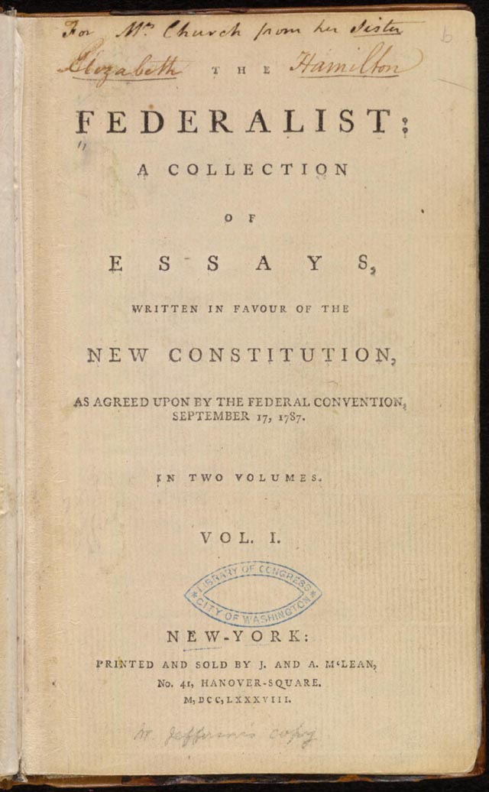

Part 1. The importance of the Union (Fed #1 - #14)
Chapter 1: Federalist 1
Chapter 2: Federalist 2
Chapter 3: Federalist 3
Chapter 4: Federalist 4
Chapter 5: Federalist 5
Chapter 6: Federalist 6
Chapter 7: Federalist 7
Chapter 8: Federalist 8
Chapter 9: Federalist 9
Chapter 10: Federalist 10
Chapter 11: Federalist 11
Chapter 12: Federalist 12
Chapter 13: Federalist 13
Chapter 14: Federalist 14

Part 2. Defects of the Articles Of Confederation (Fed #15 - #22)
Chapter 1: Federalist 15
Chapter 2: Federalist 16
Chapter 3: Federalist 17
Chapter 4: Federalist 18
Chapter 5: Federalist 19
Chapter 6: Federalist 20
Chapter 7: Federalist 21
Chapter 8: Federalist 22

Part 3. Arguments for the type of government contained in the Constitution (Fed #23 - #36)
Chapter 1: Federalist 23
Chapter 2: Federalist 24
Chapter 3: Federalist 25
Chapter 4: Federalist 26
Chapter 5: Federalist 27
Chapter 6: Federalist 28
Chapter 7: Federalist 29
Chapter 8: Federalist 30
Chapter 9: Federalist 31
Chapter 10: Federalist 32
Chapter 11: Federalist 33
Chapter 12: Federalist 34
Chapter 13: Federalist 35
Chapter 14: Federalist 36

Part 4. The Republican form of government (Fed #37 - #51)
Chapter 1: Federalist 37
Chapter 2: Federalist 38
Chapter 3: Federalist 39
Chapter 4: Federalist 40
Chapter 5: Federalist 41
Chapter 6: Federalist 42
Chapter 7: Federalist 43
Chapter 8: Federalist 44
Chapter 9: Federalist 45
Chapter 10: Federalist 46
Chapter 11: Federalist 47
Chapter 12: Federalist 48
Chapter 13: Federalist 49
Chapter 14: Federalist 50
Chapter 15: Federalist 51

Part 5. The Legislative Branch (Fed #52 - #66)
Chapter 1: Federalist 52
Chapter 2: Federalist 53
Chapter 3: Federalist 54
Chapter 4: Federalist 55
Chapter 5: Federalist 56
Chapter 6: Federalist 57
Chapter 7: Federalist 58
Chapter 8: Federalist 59
Chapter 9: Federalist 60
Chapter 10: Federalist 61
Chapter 11: Federalist 62
Chapter 12: Federalist 63
Chapter 13: Federalist 64
Chapter 14: Federalist 65
Chapter 15: Federalist 66

Part 6. The Executive Branch (Fed #67 - #77)
Chapter 1: Federalist 67
Chapter 2: Federalist 68
Chapter 3: Federalist 69
Chapter 4: Federalist 70
Chapter 5: Federalist 71
Chapter 6: Federalist 72
Chapter 7: Federalist 73
Chapter 8: Federalist 74
Chapter 9: Federalist 75
Chapter 10: Federalist 76
Chapter 11: Federalist 77

Part 7. The Judicial Branch (Fed #78 - #83)
Chapter 1: Federalist 78
Chapter 2: Federalist 79
Chapter 3: Federalist 80
Chapter 4: Federalist 81
Chapter 5: Federalist 82
Chapter 6: Federalist 83

Part 8. Conclusions & Miscellaneous Ideas (Fed #84 & #85)
Chapter 1: Federalist 84
Chapter 2: Federalist 85

Share this page Wiki Address: https://wiki.conventionofstates.com
Convention of States Youtube Channel
Convention of States on Rumble

Sign the COS Petition, be a leader https://conventionofstates.com/take_action
Volunteer here https://conventionofstates.com/take_action/volunteer

(540)441-7227 | CONVENTIONOFSTATES.COM | Facebook.com/ConventionOfStates | Twitter.com/COSproject| Email us

