
The protection of liberty requires a strict adherence to the principle that power is limited and delegated.

A Solution As Big As The Problem

Michael P. Farris, JD, LLM, Convention of States Action — Senior Fellow for Constitutional Studies

We See Four Major Abuses Perpetrated by the Federal Government.

These abuses are not mere instances of bad policy. They are driving us towards an age of “soft tyranny” in which the government does not shatter men’s wills but “softens, bends, and guides” them. If we do nothing to halt these abuses, we run the risk of becoming nothing more than “a flock of timid and in-dustrious animals, of which the government is the shepherd.” (Alexis de Tocqueville, Democracy in America, 1840)

1. The Spending and Debt Crisis

The $17 trillion national debt is staggering, but it only tells part of the story. Under stan-dard accounting practices, the federal gov-ernment owes around $100 trillion more in vested Social Security benefits and other pro-grams. This is why the government cannot tax its way out of debt. Even if it confiscated everything, it would not cover the debt.
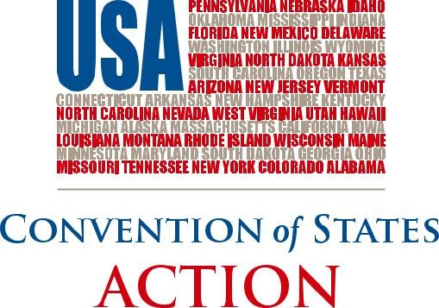

2. The Regulatory Crisis

The federal bureaucracy has placed a regula-tory burden upon businesses that is com-plex, conflicted, and crushing. Little account-ability exists when agencies—rather than Congress—enact the real substance of the law. Research from the American Enterprise Institute shows that, since 1949, federal regu-lations have lowered the real GDP growth by 2% and made America 72% poorer.

- Congressional Attacks on State Sovereignty

For years, Congress has been using federal grants to keep the states under its control. Combining these grants with federal mandates (which are rarely fully funded), Congress has turned state legislatures into their regional agencies rather than re-specting them as truly independent repub-lican governments.

A radical social agenda and an invasion of the rights of the people accompany all of this. While significant efforts have been made to combat this social erosion, these trends defy some of the most impor-tant principles.

- Federal Takeover of the Decision-Making Process

The Founders believed that the structures of a limited government would provide the greatest protection of liberty. Not only were

there to be checks and balances between the branches of the federal government, but power was to be shared between the states and federal government, with the latter only exercising those powers specifically granted in the Constitution.

Collusion among decision-makers in Wash-ington, D.C., has replaced these checks and balances. The federal judiciary supports Con-gress and the White House in their ever-escalating attack upon the jurisdiction of the fifty states.

We need to realize that the structure of deci-sion-making matters. Who decides what the law shall be is as important as what is de-cided. The protection of liberty requires a strict adherence to the principle that power is limited and delegated.

Washington, D.C., does not believe in this principle, as evidenced by an unbroken prac-tice of expanding the boundaries of federal power. In a remarkably frank admission, the Supreme Court rebuffed a challenge to fed-eral spending power, despite acknowledging that power had grown far beyond the bounds envisioned by the Founders.

What Does this Mean?

This is not a partisan issue. Washington, D.C., will never voluntarily relinquish mean-

Continued to back page

The Founders gave us a legitimate path to save our liberty. We must use the power granted to the states in the Constitution.

Continued from front page

ingful power—no matter who is elected. The only rational conclusion is this: Unless some political force outside of Washington, D.C., intervenes, the federal government will con-tinue to bankrupt this nation, embezzle the legitimate authority of the states, and de-stroy the liberty of the people. Rather than securing the blessings of liberty for future generations, Washington, D.C., is on a path that will enslave our children and grandchil-dren to the debts of the past. The problem is big, but we have a solution. Article V gives us a tool to fix the mess in D.C.

Our Solution Is Big Enough to Solve the Problem

Rather than calling a convention for a spe-cific amendment, Convention of States Action (COSA) urges state legislatures to properly use Article V to call a convention for a particular subject—reducing the power of Washington, D.C. It is important to note that a convention for an individual amend-ment (e.g., a Balanced Budget Amendment) would be limited to that single idea. Requir-ing a balanced budget is a great idea that COSA fully supports. Congress, however,


could comply with a Balanced Budget Amendment by simply raising taxes. We need spending restraints as well. We need restraints on taxation. We need prohibitions against improper federal regulation. We need to stop unfunded mandates.

A Convention of States needs to be called to ensure that we are able to debate and impose a complete package of restraints on the misuse of power by all branches of the federal government.

What Sorts of Amendments Could Be Passed?

The following are examples of amendment topics that could be discussed at a conven-tion of states:

- A Balanced Budget Amendment

- A redefinition of the General Welfare Clause (the original view was that the federal government could not spend money on any topic within the jurisdiction of the states)

- A redefinition of the Commerce Clause (the original view was that Congress was granted a narrow and exclusive power to regulate shipments across state lines–not all the economic activity of the nation)


- A prohibition on using international treaties and law to govern the domestic law of the United States

- A limitation on using executive orders and federal regulations to enact laws (since Congress is supposed to be the exclusive agency to enact laws)

- Imposing term limits on Congress and the Supreme Court

- Placing an upper limit on federal taxation

- Requiring the sunset of all existing federal taxes and a super-majority vote to replace them with new, fairer taxes

Of course, these are merely examples of what would be up for discussion. The Convention of States itself would deter-mine which ideas deserve serious considera-tion, and it would take a majority of votes from the states to formally pro-pose any amendments.

The Founders gave us a legitimate path to save our liberty by using our state govern-ments to impose binding restraints on the federal government. We must use the power granted to the states in the Constitution.


(540) 441-7227 | COSACTION.COM | Facebook.com/COSAction | Twitter.com/COSAction

