
One source of security we have... is the courts’ long history of protecting the integrity of the [amendment] procedure.

How the Courts have Clarified the Constitution’s Amendment Process

Robert Natelson, Independence Institute’s Senior Fellow in Constitutional Jurisprudence and Head of the Institute’s Article V Information Center

One source of security we have in using the Constitution’s amendment process is the courts’ (including the U.S. Supreme Court) long history of protecting the integrity of the procedure.

Many of those who pontificate on the subject are largely unaware of this jurisprudence. As a result, they often debate questions that the courts have long resolved or promote scenarios (such as the “runaway” scenario) that the law has long foreclosed.

Here are some of the key issues the courts have addressed, either in binding judgments or in what lawyers call “per-
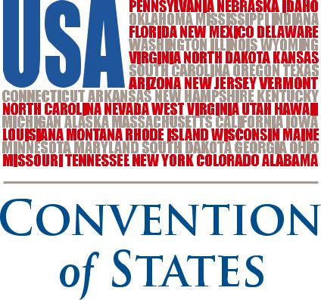

suasive authority.” This listing of cases is only partial.

- Article V grants enumerated powers to named assemblies—that is, to Congress, state legislatures, conventions for propos-ing amendments, and state conventions. When an assembly acts under Article V, that assembly executes a “federal func-tion” different from whatever other responsibilities it may have. Hawke v. Smith, 253 U.S. 221 (1920); Leser v. Gar-nett, 258 U.S. 130 (1922); State ex rel. Donnelly v. Myers, 127 Ohio St. 104, 186

N.E. 918 (1933); Dyer v. Blair, 390 F. Supp.

1291 (N.D. Ill. 1975) (Justice Stevens).

- Article V gives authority to named assemblies, without participation by the executive. Hollingsworth v. Virginia, 3 U.S. (3 Dall.) 378 (1798).

- Where the language of Article V is clear, it must be enforced as written. United States v. Sprague, 282 U.S. 716 (1931).

- That does not mean, as some have claimed, that judges may never go

beyond reading the words and guessing what they signify. Rather, a court may con-sider the history underlying Article V. Dyer v. Blair, 390 F. Supp. 1291 (N.D. Ill. 1975) (Justice Stevens). It may also con-sider what is implied as well as what is expressed. Dillon v. Gloss, 256 U.S. 368 (1921). In other words, courts apply the same rules of interpretation to Article V as elsewhere.

- Just as other enumerated powers in the Constitution bring with them certain inci-dental authority, so also do the powers enumerated in Article V. State ex rel. Donnelly v. Myers, 127 Ohio St. 104, 186 N.E. 918 (1933). This point and the one previous are important in determining the scope of such Article V words as “call,” “convention,” and “application.”

- The two - thirds vote required in Congress for proposing amendments is two thirds of a quorum present and voting, not of the entire membership.

Continued to back page
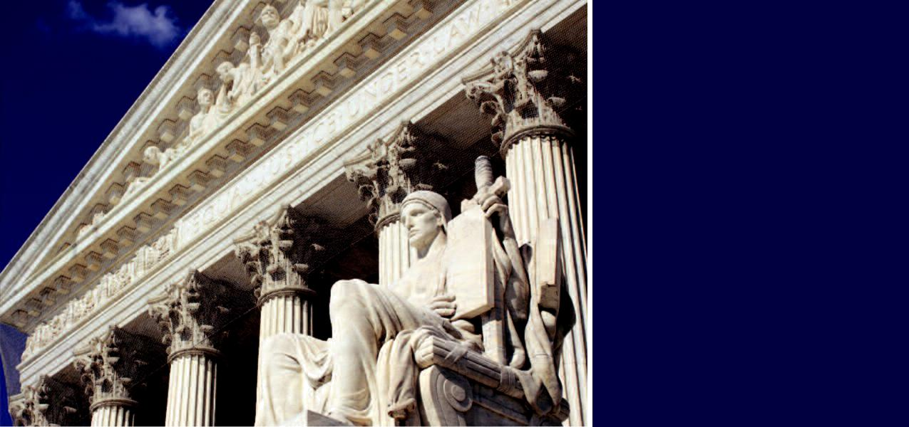
The courts are very

much in the business

of protecting

Article V procedures,

and they have done

so for more than

two centuries.

Continued from front page

State of Rhode Island v. Palmer, 253

U.S. 320 (1920).

- A convention for proposing amend-ments is, like all of its predecessors, a “convention of the states.” Smith v. Union Bank, 30 U.S. 518, 528 (1831). The national government is not concerned with how Article V conventions or state legislatures are constituted. United States v. Thibault, 47 F.2d 169 (2d Cir. 1931).

- No legislature or convention has power to alter the ratification procedure. That is fixed by Article V. Hawke v. Smith, 253 U.S. 221 (1920); United States v. Sprague,

282 U.S. 716 (1931). Some “runaway” alarmists have suggested that a convention for proposing amendments could decree ratification by national referendum, but the Supreme Court has ruled this out. Dodge v. Woolsey, 59 U.S. 331 (1855). Neither can a state mutate its own ratifying proce-
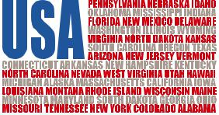

dure into a referendum. State of Rhode Island v. Palmer, 253 U.S. 320 (1920).

- Congress may not try to manipulate the ratification procedure, other than by choosing one of two specified “modes of ratification.” Idaho v. Freeman, 529 F. Supp. 1107 (D. Idaho 1981), a judgment vacated as moot by Carmen v. Idaho, 459

U.S. 809 (1982); compare United States v. Sprague, 282 U.S. 716 (1931).

- A convention meeting under Article V may be limited to its purpose. In Re Opinion of the Justices, 204 N.C. 306, 172

S.E. 474 (1933).

- But an outside body may not dictate an Article V assembly’s rules and procedures.

Leser v. Garnett, 258 U.S. 130 (1922); Dyer v. Blair, 390 F. Supp. 1291 (N.D. Ill. 1975) (Justice Stevens).

- Nor may the assembly be compelled to resolve the issue presented to it in a


particular way. State ex rel. Harper v.

Waltermire, 691 P.2d 826 (1984); AFL-

CIO v. Eu, 686 P.2d 609 (Cal. 1984); Miller v. Moore, 169 F.3d 1119 (8th Cir. 1999); Gralike v. Cook, 191 F.3d 911, 924-25 (8th Cir. 1999), affirmed on other grounds sub nom. Cook v. Gralike, 531 U.S. 510 (2001); Barker v. Hazeltine, 3 F. Supp. 2d 1088, 1094 (D.S.D. 1998); League of Women Voters of Maine v. Gwadosky, 966 F. Supp. 52 (D. Me. 1997); Donovan v. Priest, 931 S.W.2d 119 (Ark. 1996).

- Article V functions are complete when a convention or legislature has acted. There is no need for other officials to pro-claim the action. United States ex rel. Widenmann v. Colby, 265 F. 398 (D.C. Cir.

1920), affirmed 257 U.S. 619 (1921).

As these cases illustrate, the courts are very much in the business of protecting Article V procedures, and they have done so for more than two centuries.


(540) 441-7227 | CONVENTIONOFSTATES.COM | Facebook.com/ConventionOfStates | Twitter.com/COSproject

